Multiple-choice section

|  |  |  |  |  |  |  |  |  |  |  |
| --- | --- | --- | --- | --- | --- | --- | --- | --- | --- | --- |
| Question | 1 | 2 | 3 | 4 | 5 | 6 | 7 | 8 | 9 | 10 |
| Answer | A | B | C | B | C | A | D | B | D | A |

Question 1 [7.1]

A

2*n* + 3 = 22

Question 2 [7.1]

B

2*a* − 5 = -11

LHS = 2(-3) − 5

LHS = -6 − 5

LHS = -11

LHS = RHS

 *a* = -3

Question 3 [7.2]

C

Where *x* = 2, *y* = 4.

Question 4 [7.2]

B

Where *y* = 0, *x* = -2.

Question 5 [7.2]

C

To obtain *x* ‘add 6 and multiply by 3’.

Question 6 [7.4]

A

4*x* + 4 = 3*x* + 6

*x* + 4 = 6

*x* = 2

Question 7 [7.3]

D

 + 5 = 2

 = 2 − 5

= -3

*b* = -3 × 4

*b* = -12

Question 8 [7.3]

B

3(*x* − 6) = 21

3*x* − 18 = 21

3*x* = 21 + 18

3*x* = 39

*x* = 13

Question 9 [7.4]

D

4*d* − 2 = 2*d* + 10

4*d* − 2*d* − 2 = 10

2*d* – 2 = 10

2*d* = 10 + 2

2*d* = 12

*d* = 

*d* = 6

Question 10 [7.5]

A

4*C* + 0.60 = 5.00

4*C* = 5.00 – 0.60

4*C* = 4.40

*C* = 

*C* = 1.10

A chocolate bar costs $1.10.

Multiple-choice total marks: 10

Short answer section

Question 11 3 marks [7.3]

(a) David’s working  
 − 5 = 7  
  = 12



(b) Correct working   
 − 5 = 7  
  = 12  
 *x* = 36

(c) David divided by 3 rather than multiplying by 3.

Question 12 3 marks [7.2]

The taxi costs $5 to hire before you go anywhere (‘flagfall’ = $5).

For 10 km the taxi charges an additional $20.

Thus the taxi charges $2 per km.

The total cost for the taxi journey can be given by the equation *c* = 2*d* + 5, where *c* is the cost and *d* is the distance in km.

Question 13 2 marks [7.1]

(a) 2*n* + 4 = 22

(b) *n* + 5 = 2*n* − 3

Question 14 4 marks [7.1]

(a) 3*x* − 5 = 13 (*x* = 6)  
LHS = 3 × 6 − 5  
= 18 − 5   
= 13  
= RHS  
So *x* = 6 is a solution.

(b) = 20 (*x* = 4)  
LHS =   
≠ RHS  
So *x* = 4 is *not* a solution.

Question 15 2 marks [7.1]

Two less than three times a number gives a result of ten.

Question 16 2 marks [7.1]

(a) *F* = *Ma* (b) *R* = 2*B* − 5

Question 17 2 marks [7.2]

3*x* + 2 = 8

3*x* = 8 – 2

3*x* = 6

*x* = 2

Question 18 4 marks [7.2]

(a) 3*c* – 5 = 4  
3*c* = 4 + 5  
3*c* = 9  
*c* =   
*c* = 3

(b) 17 + 5*b* = 32  
5*b* = 32 − 17  
5*b* = 15  
*b* =  
*b* = 3

Question 19 4 marks [7.2]

(a) *y* = 1 (b) *y* = -1

(c) *x* = -1 (d) *x* = 0

Question 20 4 marks [7.2]

(a) 3*a* − 5 = -17  
3*a* = -17 + 5  
3*a* = -12  
*a* =   
*a* = -4

(b)  + 3*x* =   
+ 3*x* =   
7 + 9*x* = 11  
  
*x* = 

Question 21 3 marks [7.2]

(a) Let the cost of a coffee be represented by the letter *c* and a sandwich by the letter *r*.

5*c* + 2*r* = 26.5

(b) 5*c* + 2(4.5) = 26.5  
5*c* + 9 = 26.5  
5*c* = 17.5  
*c* =   
*c* = 3.5

So the cost of a cup of coffee is $3.50.

Question 22 6 marks [7.3]

(a) = 7  
2*x* − 3 = 7 × 5  
2*x* − 3 = 35  
2*x* = 38  
*x* =   
*x* = 19

(b) + 8 = 5  
= 5 − 8  
 = -3  
3*x* = -3 × 4  
3*x* = -12  
*x* =   
*x* = -4

Question 23 6 marks [7.3]

(a) 3(*x* − 5) = 21  
3*x* − 15 = 21  
3*x* = 21 + 15  
3*x* = 36  
*x* =   
*x* = 12

(b) 4(3*x* + 2) = 44  
12*x* + 8 = 44  
12*x* = 44 − 8  
12*x* = 36  
*x* =   
*x* = 3

Question 24 6 marks [7.3]

(a) 2*n* − 6 = 8  
2*n* = 8 + 6  
2*n* = 14  
*n* =   
*n* = 7

(b) 3(*n* − 3) = 18  
3*n* – 9 = 18  
3*n* = 18 + 9  
3*n* = 27  
*n* =   
*n* = 9

Question 25 4 marks [7.3]

**(a)**

Perimeter = 2*w* + *w* + 2*w* + *w*  
Perimeter = 6*w*  
420 = 6*w*  
6*w* = 420

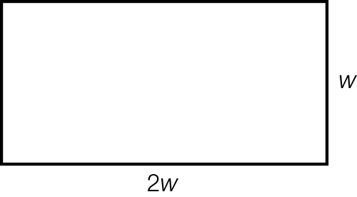

**(b)** *w* = 

*w* = 70

Thus the width is 70 metres and the length 2*w* is 140 metres.

Question 26 3 marks [7.4]

3*x* + 8 = 5*x +* 4

3*x* − 5*x =* 4 – 8

-2*x* = -4

*x* = 2

Question 27 6 marks [7.4]

(a) 5*x* − 4 = 2*x* + 5  
5*x* − 2*x* − 4 = 5  
3*x* − 4 = 5  
3*x* = 5 + 4  
3*x* = 9  
*x* =   
*x* = 3

(b) 3*x* + 4 = 8*x* − 11  
4 = 8*x* − 3*x* − 11  
4 = 5*x* − 11  
4 + 11 = 5*x*   
5*x* = 15  
*x* =   
*x* = 3

Question 28 6 marks [7.4]

(a) 3*x* − 6 = 2(*x* + 5)  
3*x* − 6 = 2*x* + 10  
3*x* − 2*x* − 6 = 10  
*x* − 6 = 10  
*x* = 10 + 6  
*x* = 16

(b) 6(*x* + 2) = 2(1 − 2*x*)  
6*x* + 12 = 2 − 4*x*6*x* + 4*x* + 12 = 2  
10*x* + 12 = 2  
10*x* = 2 − 12  
10*x* = -10  
*x* =   
*x* = -1

Question 29 6 marks [7.4]

(a)  =   
2(2*x* − 3) = 5(3*x* + 1)  
4*x* − 6 = 15*x* + 5  
-6 = 15*x* − 4*x* + 5  
-6 = 11*x* + 5  
-6 − 5 = 11*x*-11 = 11*x  
x* =   
*x* = -1

(b)  =   
5(3 − *x*) = 3(1 − 2*x*)  
15 − 5*x* = 3 − 6*x*15 − 5*x +* 6*x* = 3  
15 + *x* = 3  
*x* = 3 – 15  
*x* = -12

Question 30 6 marks [7.4]

(a) 2 − *x* = *x*

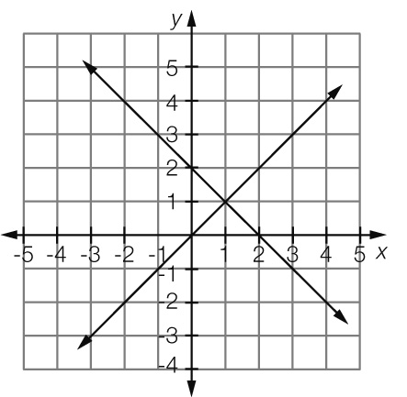

*x* = 1

(b) 3*x* + 5 = 1 − *x*

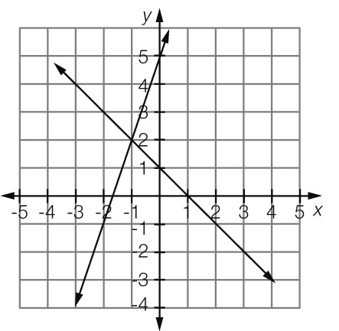

*x* = -1

Short answer total marks: 82

Extended answer section

Question 31 5 marks [7.2, 7.5]

(a) *C* = 0.5 + 0.12 × 6 × *n  
C* = 0.5 + 0.72*n*

(b) *C* = 0.5 + 0.72 × 11  
*C* = $8.42

(c) *C* = 5 × 0.5 + 50 × 0.72  
*C* = $38.50

(d) Total usage = calls + SMS  
 = $213 + (0.22 × 793)   
 = $387.46  
Charges = $35 + $387.46 − $350 = $72.46  
So Peta’s bill for the month is $72.46.

Question 32 10 marks [7.3, 7.5]

(a)

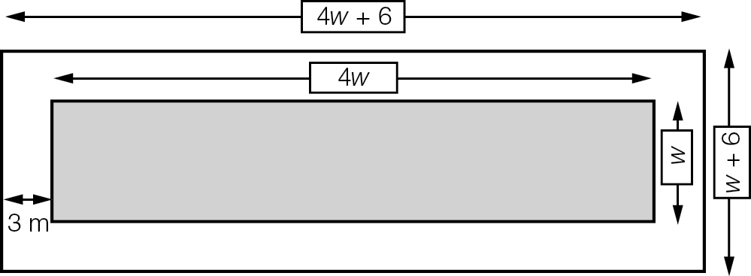

(b) *P* = 2(4*w* + 6 + *w* + 6)  
*P* = 2(5*w* + 12)  
*P* = 10*w* + 24

(c) 10*w* + 24 = 174  
10*w* = 174 − 24  
10*w* = 150  
*w* =   
*w* = 15  
Thus the width is 15 m and the length is 4 × 15 = 60 m

(d) (i) *A* + *C* = 420, but there are twice as many children as adults so *C* = 2*A*Substituting the *C* with 2*A* gives  
*A* + 2*A* = 420  
3*A* = 420  
*A* = 140  
Thus there are 140 adults at the pool.

(ii) Number of children = 420 – *A*   
 = 420 – 140  
 = 280  
Entry fee collection = 140 × 4 + 280 × 2  
= 560 + 560  
= $1120

Extended answer total marks: 15

TOTAL test marks: 107